|  |  |
| --- | --- |
| **Important Dates:**  5/2- Teacher Appreciation Week Begins (Please see flyer that was sent home for ideas to celebrate staff.)  5/3 KCS Inservice Day **(No School)**  5/5- Last CRRAFT Family Night (6:00-7:00)  5/6- **PK4 Cap and Gown Money Due** (Please send your money to school if you haven’t done so already.)  5/6- National School Lunch Hero Day  5/6- Fair Garden’s Mother Day Event (at arrival)  5/7-Fair Garden’s **PTA Spring Carnival** in the Fair Garden Parking Lot (1:00-3:00)  5/11- PK3 Students’ Field Trip  5/20- PK4 Stepping Up Program at 9:00 (More information to come home from your child’s teacher)  5/23- 4th Nine Weeks PBIS Students’ Bubbles Behavior Celebration  5/24- **Awards Day** for students with **perfect attendance** for the whole year with Mrs. Spikes/**Awards Day** in each individual class  5/25- Last Day For Students/Student Performance Level Reports Will Be Sent Home (**11:15 am Dismissal**)  Logo, company name  Description automatically generated A picture containing text  Description automatically generated Text  Description automatically generated  images.jpegThe Guiding Light images.jpeg  Volume 3 Issue 9 <https://www.knoxschools.org/fairgarden> Published Monthly **May 2022** | Screen%20Shot%202018-08-31%20at%2010.17.55%20AM.pngScreen%20Shot%202018-08-31%20at%2010.17.55%20AM.png  **A Note From Our Social Worker- Deanna Gnage**  **Is the Thought of Summer Vacation Making You Crazy?**  You’ve got this, Parents and Guardians!   Your children look forward to summer vacation and yet they likely complain about being hot, lonely, and having nothing to do.   Some children are content to sit and play, read, or be active outside.  However, many are restless and make you pull your hair out.  What can you do during the summertime to help your children stay safe and pleasant while preventing you from going crazy?  First, give them a schedule.  Kids THRIVE on structure and routine!  A few tips for setting up a schedule.  Make sure your children’s meals are eaten at approximately the same time every day.  Alternate low energy and high energy activities.  So, if your child sits and plays with toys for 20 minutes, send them outside to run, skip, play in a sandbox, or to find 4 items you tell them to look for (i.e. stick, worm, 3 leaf clover, a pebble the size of a dime).  After they’ve gotten rid of some energy, they can be ready to play inside for short periods of time again.  Also, keep your little ones on the same bedtime schedule they had during the school year.  You can allow them to stay up a half hour or hour later but make sure your routine looks the same:   Bath, pajamas, teeth brushed, and a story read before lights are turned out.  It stays lighter outside for longer now so allow your children to read a stack of books until they are sleepy enough to try and fall asleep.  My children were allowed to choose whether they wanted to go to sleep at 8:00 p.m. or stay up (they had to be in their beds) till 8:30 p.m. by reading for that half hour.  They always opted to stay up by reading.  Win-win!  If you are able, keep your children’s screen time usage to educational videos that are appropriate for your child’s age.  Remember though, children learn through REAL play.  I’ve watched your children mimic YOU in a play kitchen.  They are often acting out intricate moves that they’ve watched you do like flipping the grilled cheese sandwich in the pan and squishing it down.  Play allows them to learn skills that will later translate to the real world, imagine their roles in life, and solve some of the things they worry about.  Also, when you play card and board games with your children, you are improving your child’s math skills.  As they match sets, colors, and numbers, it is reinforcing their numbers and one-to-one correspondence.  They are also learning valuable social skills such as sharing, patiently waiting for a turn, and being a good sport whether they win or lose.   Some more ideas? Children love treasure hunts!  You don’t even have to offer money or toys as prizes but can allow each child to celebrate with an ice cream cone if they follow the simple clues you give and find the object you hid.  Treasure hunts are masterful for teaching children problem-solving!  Lastly, but most importantly?  Just read to your children.  Read a book or two and then have them read to you.  They may not be able to truly “read” but you’d be surprised how many letters they can identify.  They are benefiting just by looking at each page and telling you what they think is happening in each picture.  Lastly, plan an activity once every 1-2 weeks. It gets your children out beyond your own 4 walls and opens up their world.  It’s really like traveling to a new land for them.  The Muse at Chilhowee Park has a free family night that allows you to see their exhibits on the 4th Friday of each month from 6-8 p.m. ([Free Family Night | Muse Knoxville](https://www.themuseknoxville.org/free-family-night)).  Burlington Library (https://www.knoxlib.org/kid-zone/storytime) hasn’t listed all their summer activities yet but they currently have a free Story Time and Lego club.  And don’t forget that Lowes offers free Children’s Do-It-Yourself Workshops.  Take a look at Lowes’ current offerings ([DIY-U by Lowe's](https://lowesdiy.com/locations/1fef5fc8-21a1-42db-847c-f0459258b173?event_type=diy-kids-workshop)).  More ideas for local summer activities for children are listed at: [Free and Inexpensive Indoor Activities for Kids](https://knoxvillemoms.com/free-and-inexpensive-indoor-activities-for-kids/).  Your children love being with you and will thrive on playing, being read to, and even doing a chore or two each day.  Don’t underestimate how much your child learns just by watching you do your work, hearing how you talk with other people, and interacting in play with you.  ***HAVE A FANTASTIC SUMMER!!***  Deanna Gnage, LMSW  Fair Garden School Social Worker  (865) 257-5826      **Please make sure to check our school-wide Dojo, your child’s class Dojo, and our school website to stay informed about events that are happening at Fair Garden.** Please join our electronic platform: **Fair Garden’s Twitter:** <https://twitter.com/fair_garden> **Thank you. ☺** |
| Positive Quote:  **Sponsored by Mike Lewis with State Farm our Partner In Education**  **Good Neighbor Teacher of the Month**  ** | large_651e2a4a-23cf-4813-b6fe-96cd6a51692e.jpg**A Message from Principal Spikes** large_651e2a4a-23cf-4813-b6fe-96cd6a51692e.jpg  Oh my, our time together just flew by so quickly. I cannot believe our PK4 students will be venturing off to kindergarten at so many different schools across Knox County. Twenty-one different schools to be exact will have a little piece of Fair Garden to start the 2022-2023 school year.  It’s funny how life comes full circle. So many of you were taught by my husband when you were in middle school. I had the extraordinary opportunity to see you all grown up with your own child. What involved, smart, and dedicated parents each of you have grown up to be. Others, this was our first-time meeting. Thank you for allowing the Fair Garden staff to be a part of your lives for this brief moment of precious time. I have enjoyed every moment of our year. I truly love every precious student and their uniqueness. I LOVE my job because of each and every one of our precious fireflies.     As you and your child venture off to the next grade level, some of you will still be here at Fair Garden, and others going off to your new school, I hope you know you are loved by your Fair Garden family. Please continue to light a path for greatness. Each of you will forever be a part of the Fair Garden family. Now you have a Fair Garden yearbook that will allow you to revisit Fair Garden more often just by the turn of a page. Until we see each other again, keep your light on and let it shine as bright as the sun. Please come back and visit us. Only together can we make a difference. Let’s continue to ignite GREATNESS, as a forever representative of Fair Garden. Farewell, and have a sensational summer! ☺  Warm regards,  Mrs. Spikes |



**Clinic Reminders:**

* Clinic Supply Needs: elastic waist pants size 3T-8, small disposable cups

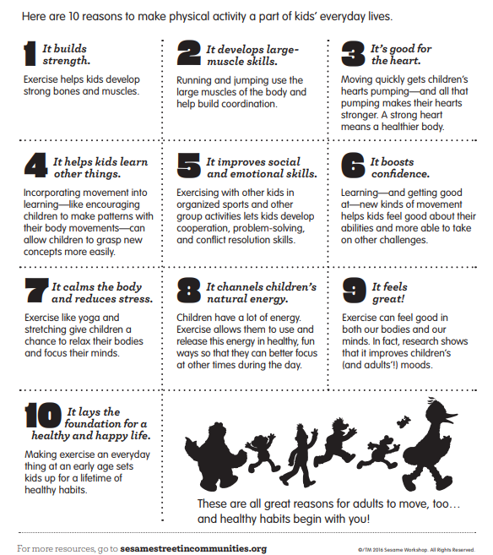

How exciting is this time?! We have so much to look forward to in the last month of school! Please read through so you can be involved in all the amazing things happening in the next few weeks.

We are loving on our Fair Garden staff with our monthly breakfasts on **Friday 4/29** as well as **Friday 5/20**.

We have Teacher Appreciation Week from 5/2-5/6, and the daily theme are as follows:

**Monday 5/2:** PTA is providing all staff with $5 gift cards! We encourage you to send your own gifts in addition to these!

**Tuesday 5/3 (No School):**PTA is giving all teachers handwritten thank you cards! We encourage you to write to your teachers and thank them for all they do for our children!

**Wednesday 5/4:** PTA is providing cupcakes to all staff! We encourage you to send in some amazing baked goods for your teachers!

**Thursday 5/5:** PTA is providing a coke/root beer float cart to all staff! We encourage you to send in your teachers' favorite drinks and snacks as well!

**Friday 5/6:** PTA is providing lunch for all staff! We encourage you to bring in a side dish or lunch item for our amazing Fair Garden staff!

**Fair Garden PTA Spring Carnival:**

**Saturday 5/7 from 1:00-3:00pm** is our first ever Fair Garden PTA Spring Carnival! Muse Knoxville will be on site providing fun STEAM activities, and we will have games and music too. We will have a bake sale to help us fundraise, so if you are interested in bringing your homemade baked goods for the sale, email us at [fairgardenpta@gmail.com](mailto:fairgardenpta@gmail.com) to let us know! Admission to the carnival is $2/person, and admission prices include access to all games and activities. Baked goods are available for additional purchase during the carnival.

And lastly, **Fair Garden PTA has created our first ever Fair Garden yearbook!**They are in printing right now and will be on site the week of 5/10. Thanks to generous donations from local businesses and PTA funds, we have subsidized the cost of the yearbook to only **$7/book**!!! That means that you get 36 pages of amazing memories from the 2021-2022 school year at Fair Garden to cherish forever for just $7. We will be sending home order forms next week to start collecting money for your yearbook.

This has been a phenomenal year at Fair Garden with the start of our first ever parent organization. We thank each and every one of you for your commitment and involvement to our children and their place of learning. We are proud of all we have started and look into the future with EXCITEMENT!

Reach out to us at any time for ways you can be involved and thank you!

**-Fair Garden PTA Officers, Allison, PJ, and Taurika**

